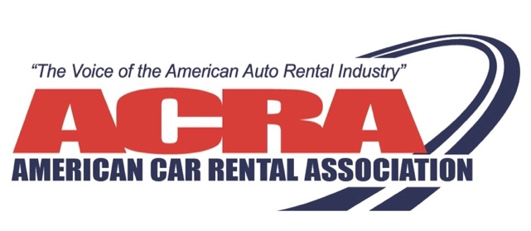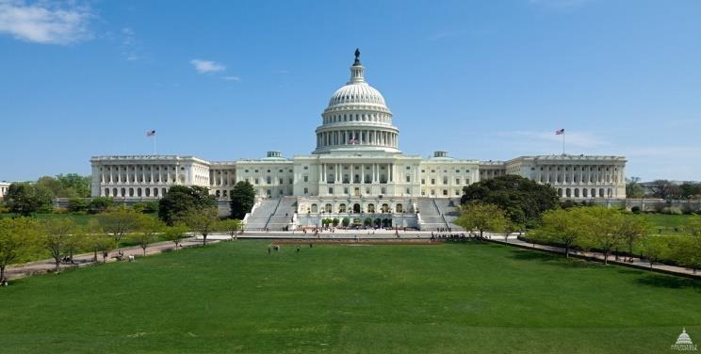

ACRA’S 2024 D.C. CAR RENTAL CONFERENCE
SEPTEMBER 15 – 18, 2024
REGISTER NOW! AFTER ACRA’S RECORD-BREAKING 2023 D.C. “BOOT CAMP”, THE 2024 CONFERNECE WILL SELL OUT AGAIN – DON’T MISS OUT!

Planning is under way for ACRA’s 2024 D.C. Car Rental Conference! Register now and get your hotel room before both the conference and the hotel sells out!

Day #1 – Operations “Boot Camp” – As an ACRA regular member, you need to be in D.C.! If you’re trying to grow your business and want to work with the experts in the car rental industry, this is the forum to use. You might be trying to decide if joining an affiliate or becoming a franchise is the right decision for your company, or finding the correct insurance company that can work with you to reduce your exposure and increase your fleet, and/or you just want to meet experienced car rental operators and learn from their success of buying and selling fleet. This is a smaller, very concentrated educational conference for the serious rental operator.
Days #2 & #3 – Policy “Boot Camp” – Both of the “policy” days during the 2024 Conference will take place on Capitol Hill. The first policy day will involve hearing from legislators, congressional staff, officials from federal agencies, and stakeholders (both supportive opposed to ACRA’s positions) regarding the key federal public policy issues facing the car rental industry, like – (1) extension of the 2017 tax reform provisions, including full expensing for personal property; (2) electric vehicle incentives (versus fleet purchase mandates); (3) GHG regulation and litigation as it relates to the car rental industry and its fleet mixture; and, (4) vehicle owner control of vehicle generated data.

The second policy day will again entail Conference attendees putting their training to practical use by meeting on Capitol Hill with legislators and their staff to promote the federal policy priorities of the American car rental industry. Both regular and associate members are the best “lobbyists” ACRA has to promote the interests of our industry. Each advocacy pack will be led by an experienced D.C. lobbyist, so you won’t be on your own on Capitol Hill!

2024’s ACRA D.C. Conference will reflect the best from 2022 and 2023 and is sure to sell out again. So, don’t delay! Secure your registration today by going to www.acraorg.com or calling Sharon Faulkner at (518-810-6091) or emailing her at sfaulkner@acraorg.com.

ACRA 2024 D.C. CAR RENTAL CONFERENCE

SCHEDULE (DRAFT AS OF 5/29/24)

HQ Hotel – Westin Arlington Gateway/Ballston (801 N. Glebe Road, Arlington, VA)

Sunday, September 15, 2024
(Dress Code – Casual)

7:00 p.m. Informal Sponsored Networking Dinner

Monday, September 16, 2024 – ACRA Car Rental ROTC/Boot Camp – Operations
(Dress Code – Business Casual)

7:30 a.m. Sponsored Networking Full Breakfast
Westin

8:30 a.m. -- Operations ROTC/Boot Camp Presentations
4:30 p.m. Westin

5:30 p.m. -- Sponsored Cocktail Party
6:30 p.m. Westin

6:30 p.m. Time Available for Supplier Hospitality

Tuesday, September 17, 2024 – ACRA Car Rental ROTC/Boot Camp – Policy
(Dress Code – Business Attire)

7:30 a.m. Sponsored Networking Full Breakfast
Westin

10:00 a.m. -- Policy ROTC/Boot Camp Presentations (including ACRA Board of Directors
4:00 p.m. Meeting)
Conference Room on Capitol Hill
Washington, D.C.

4:30 p.m. ACRAPAC Congressional Reception (Open to 2024 ACRAPAC Contributors Only)

7:00 p.m. Time Available for Supplier Hospitality

Wednesday, September 18, 2024 -- ACRA ROTC/Boot Camp – From Discussion to Action
(Dress Code – Business Attire)

7:30 a.m. Sponsored Continental Breakfast and Congressional Briefing
Westin

10:00 a.m. -- Meetings on Capitol Hill with Regional Groups and Experienced Lobbyist “Squire”
4:00 p.m.

12:00 noon Lunch on Own on Hill Depending on Meeting Schedule

4:00 p.m. Depart Capitol Hill for Hotel

5:00 p.m. Depart for Airport

